SQL queries

This is all the queries that I have used.

1. **Get familiar with the company**

**How many campaigns did CoolTshirts use?**



**How many sources did CoolTshirts use?**



**How are they related?**

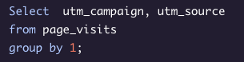

**What pages are on the website?**



**2. What is the user journey?**

**How many first touches is each campaign responsible for?**

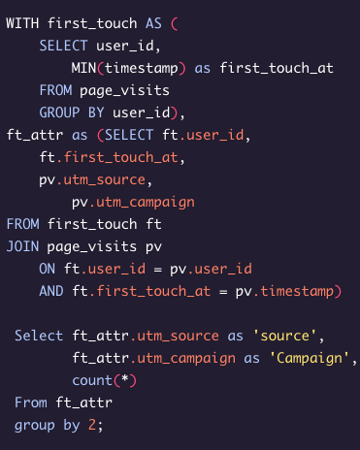

**How many last touches is each campaign responsible for?**

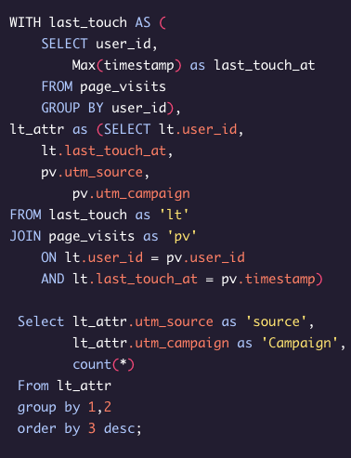

**How many visitors make a purchase?**

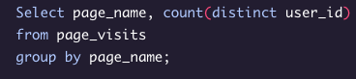

**How many last touches *on the purchase page* is each campaign responsible for?**

